HOMEWORK WRITE UP

**makeData.java**

Make data starts off with the usual for these homework's. Checking for the argument size and getting the user data. Then we seed our random number object with 42 as specified. Next, we check if lower is greater than upper. If it is, this will cause an error. The next thing we do is use a try catch block and initialize the binary output stream. Inside of the try block we write our meta data to the file, that being the number of items to print. Next, we loop through the amount of number of items and create our random numbers and write that to the file. I did not include timing in this program as it was not specified.

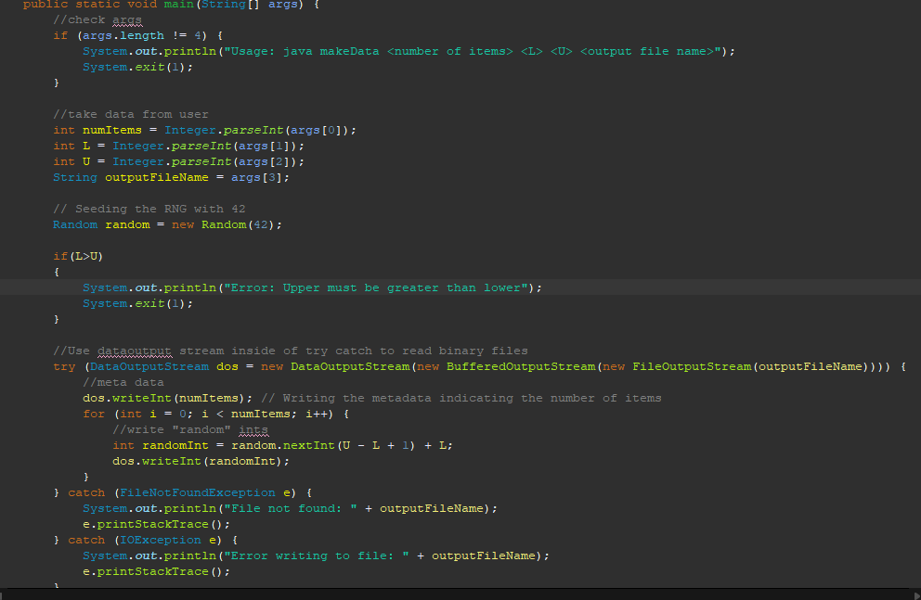  
**DP.java**

Checks args for elements and then starts the timer. Program attempts to initialize datainput stream to read binary data inside of a try block.

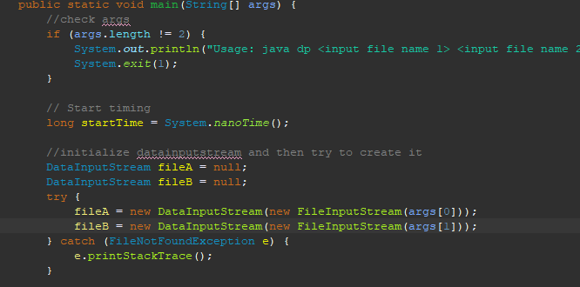

Next thing is to try and read the file for the number of elements. This is done inside of a try catch. If there is no error the program, then creates the arrays initialized with the number of elements and then reads the rest of the data out of the file inside of a try catch and for loop.

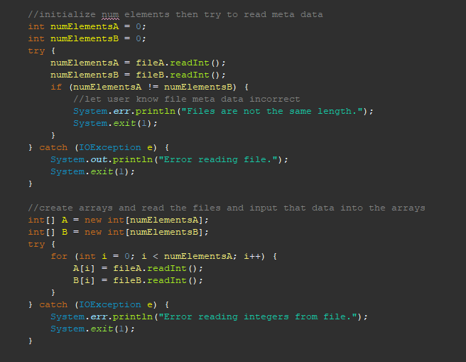

The next thing the program does is time the calc_dp function and execute that function. The calc_dp function sums up the multiples of each element in the array. Next, the program finishes its total time and prints specified data to the screen.

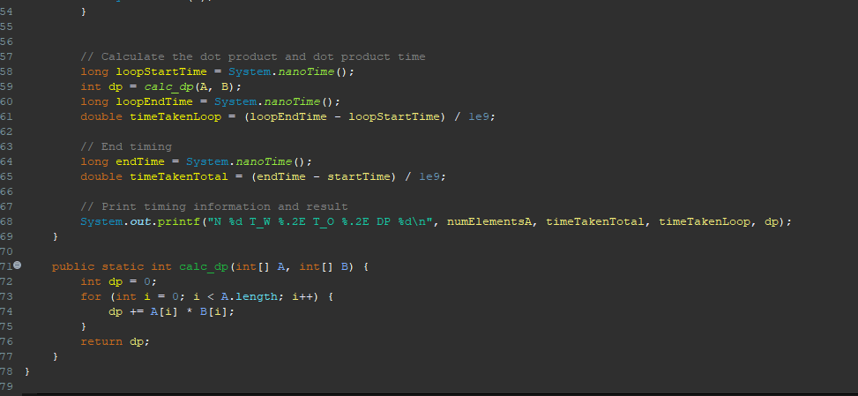

HOMEWORK SCREENSHOTS  
